研 究 計 画 書

Research Plan
志願者氏名  Applicant's Name | Firstname Lastname |  | 受験番号  App. No. | ※1
教育研究領域  Field of Study | 領域１つを○で囲むこと。 Circle a Field of Study.
 | CS SY CN IT SE PM
予定指導教員  Prospective Research Adviser | 氏名 Name | 押印または署名 Seal or Signature ※2
 | RAGE Uday Kiran
英文で記述すること。 Write in English.

Research Title: Discovering Hidden Periodic Patterns in Temporal Databases

Temporal databases are an essential part of many big data applications, as they provide data that contains information about time. Within this temporal data, there lies valuable information that can empower end-users with competitive knowledge. In this context, periodic-frequent pattern mining has emerged as a critical technique in data mining. The goal of this approach is to discover all periodically occurring frequent patterns in a temporal database, which can reveal insightful information about the underlying processes and behaviors.

To achieve this goal, periodic-frequent pattern mining involves discovering all interesting patterns in a temporal database that satisfy user-specified constraints, such as minimum support (minSup) and maximum periodicity (maxPer). The minSup constraint specifies the minimum number of transactions a pattern must appear in a database, while maxPer controls the maximum time interval within which a pattern must reappear. However, previous studies have shown that existing periodic-frequent pattern mining methods tend to generate too many redundant patterns, making it challenging to extract relevant information from the data.

To address this issue, I intend to propose a novel model that focuses on discovering a concise set of periodic patterns with a reduced search space. This approach involves introducing various techniques and constraints to develop fast and memory-efficient algorithms that can effectively prune the redundant patterns. The main challenges in this research include the high search space required to store the patterns, the computational cost of computing the expected support of the pattern, and the large number of redundant patterns generated. To overcome these challenges, the proposed model will employ several optimization techniques, such as constraint-based pruning and frequent pattern aggregation.

The Main Challenges are:

1. Search space: The space consumed to store the patterns is very high. Consumes a lot of memory

2. Computational cost: Computation of the support and periodicity of the pattern is costly.

3. Redundant Patterns: Too many patterns are generated, resulting the time, memory, and energy consumption. I am pruning the redundant patterns.

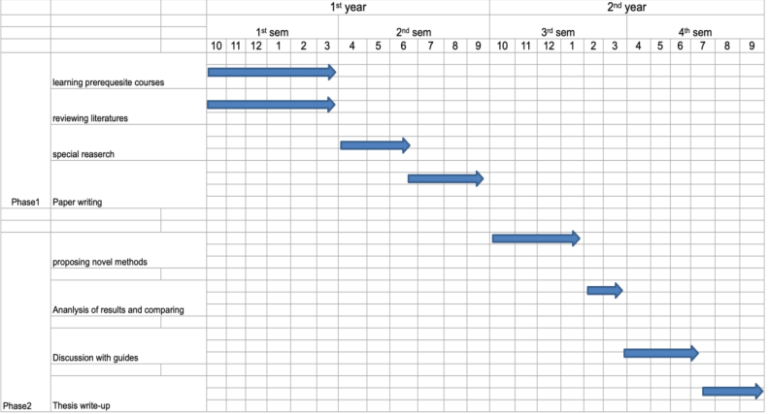
The Research schedule to reach the goal:
※1 記入しないこと。 Do not write in the box.
※2 入学後の研究計画について、出願の前に必ず指導を受けようとする教員に承認を得ること。遠隔地に居住している等の理由により、押印や署名を得られない場合は、教員が了承していることを示すE-mailの写しを添付すること。
Prior to making the application, you must obtain approval from your prospective research adviser regarding this research plan. If you are in a remote place and not able to obtain a seal or a signature, a copy of an email that verifies their agreement should be attached.

